NAME :B.THARUN KUMAR REDDY

REG.NO :192111508

COURSE :COMPUTER NETWORKS

CODE :CSA0719

FACULTY :DR G.ANITHA

**LAB MANUAL 1 TO 5**

1.Configuration of Network Devices using Packet Tracer (Hub, Switch, Ethernet, Broadcast)

**HUB**

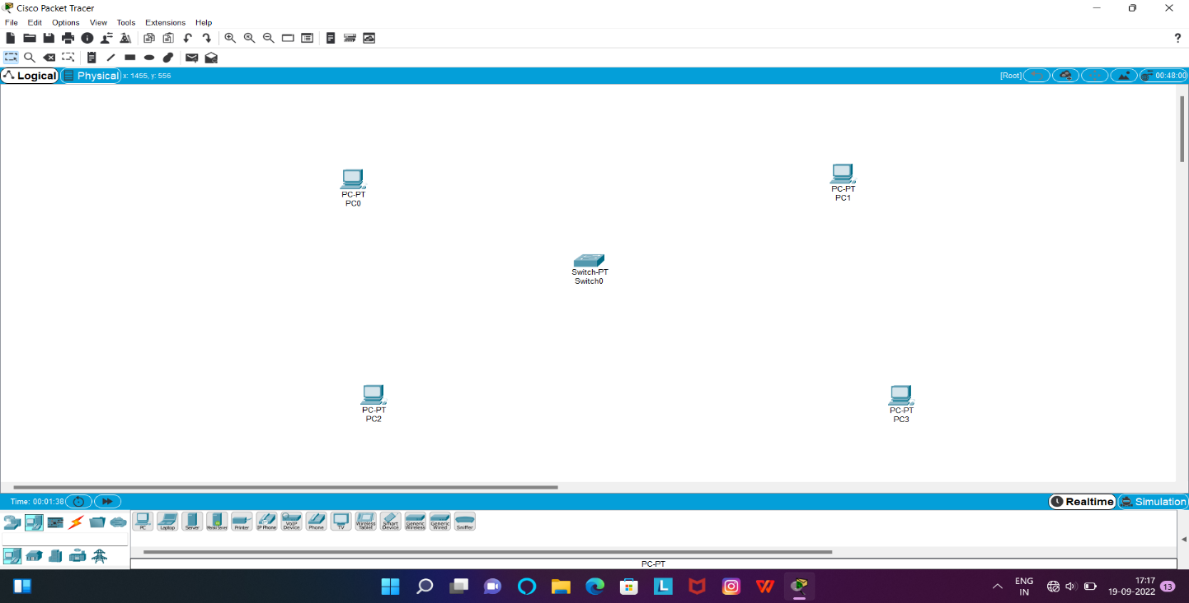

**SWITCH**

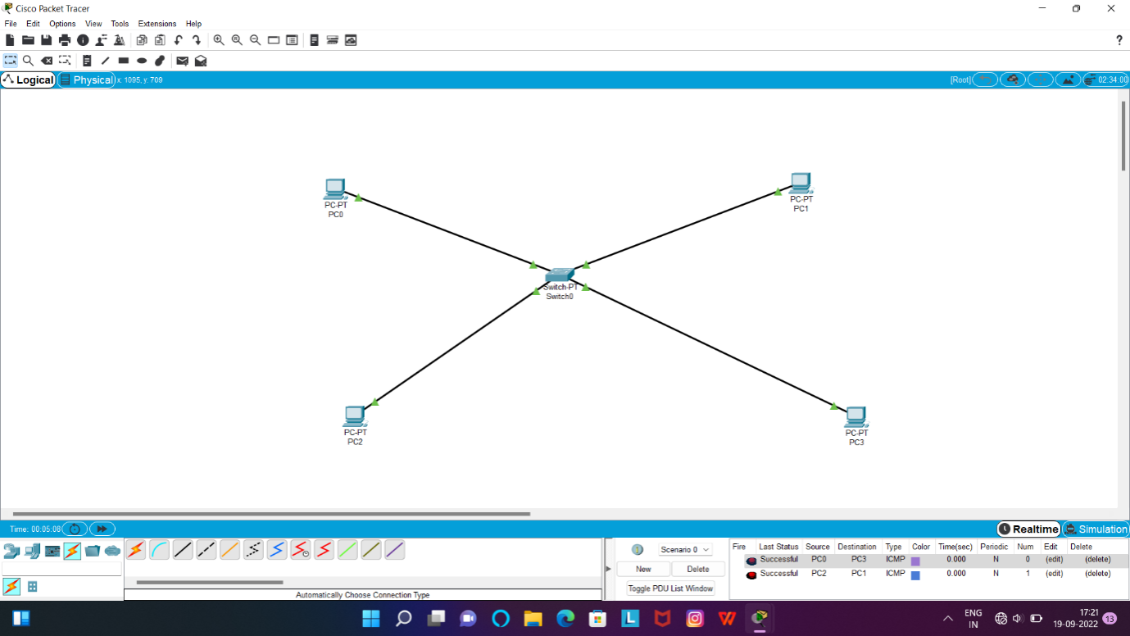

**ETHERNET**

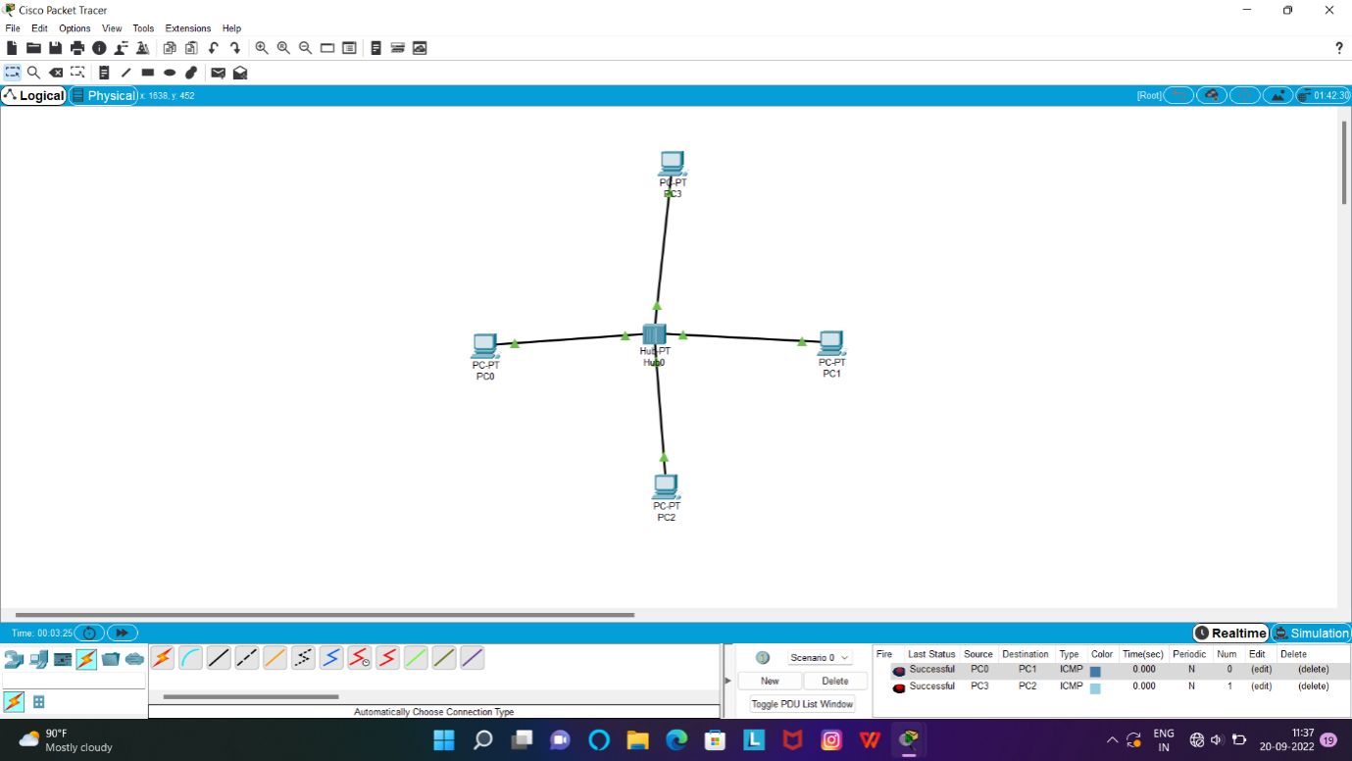

**BROADCAST:**

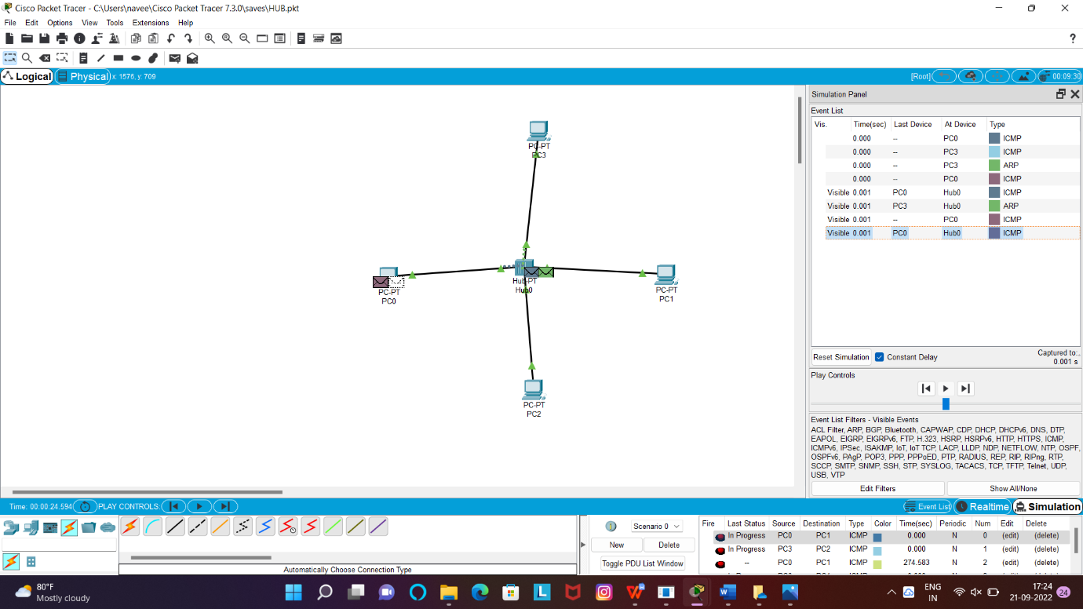

2.Configuration of Topologies using Packet Tracer (Star, Mesh, Tree,)

**TREE :**

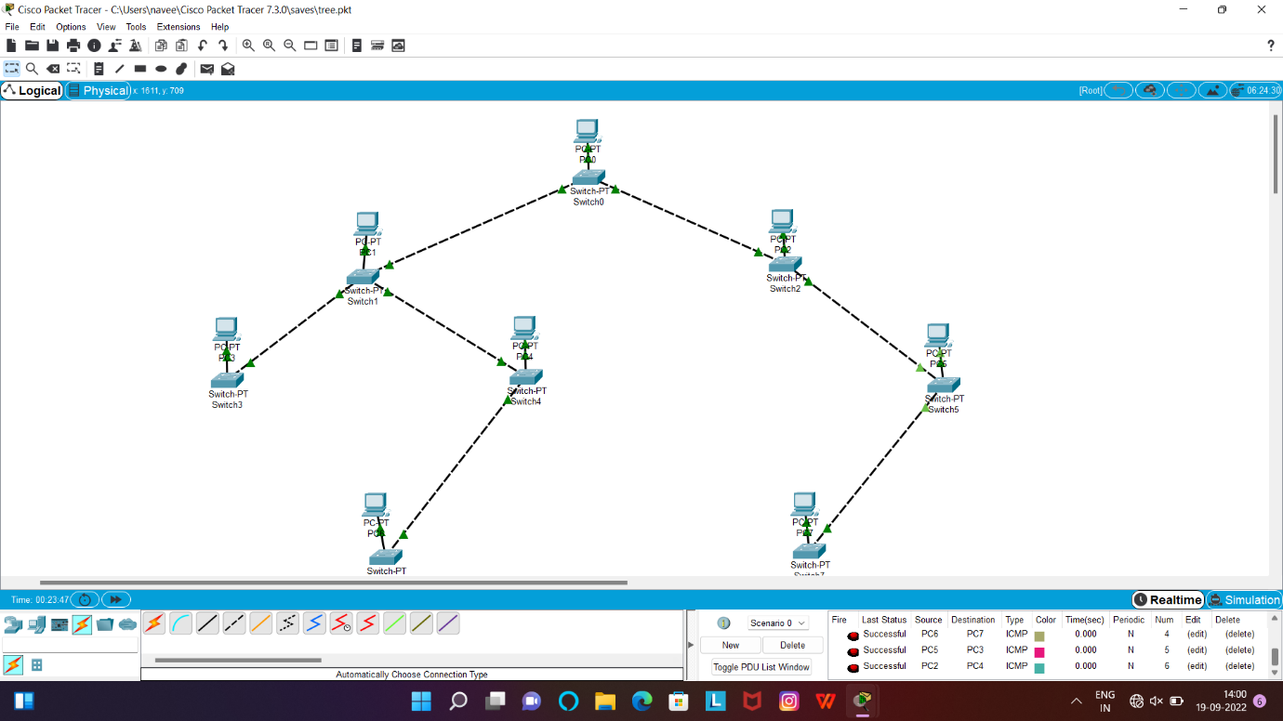

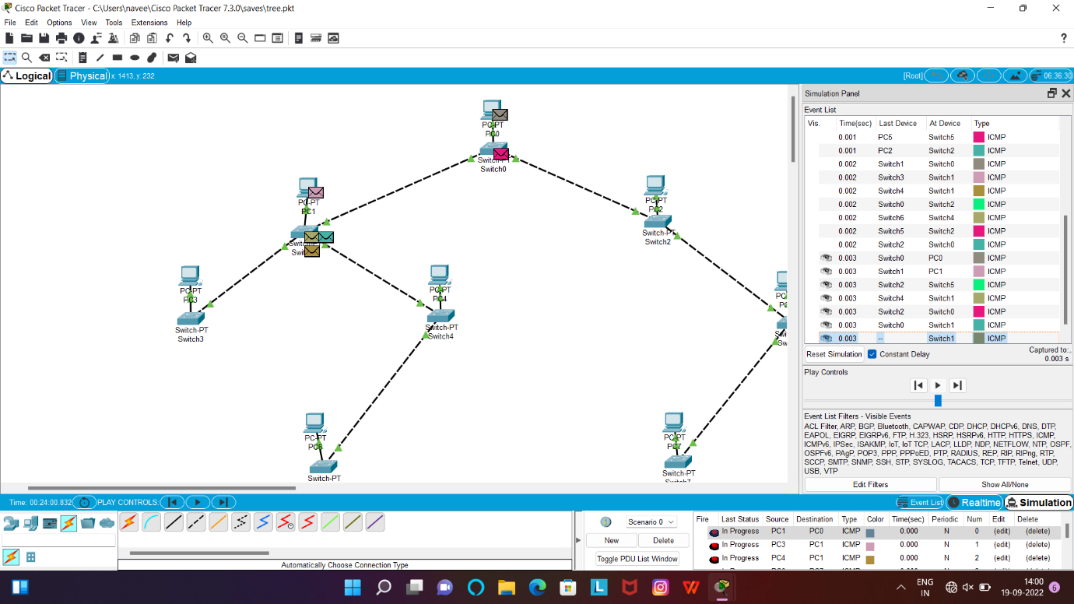

STAR:

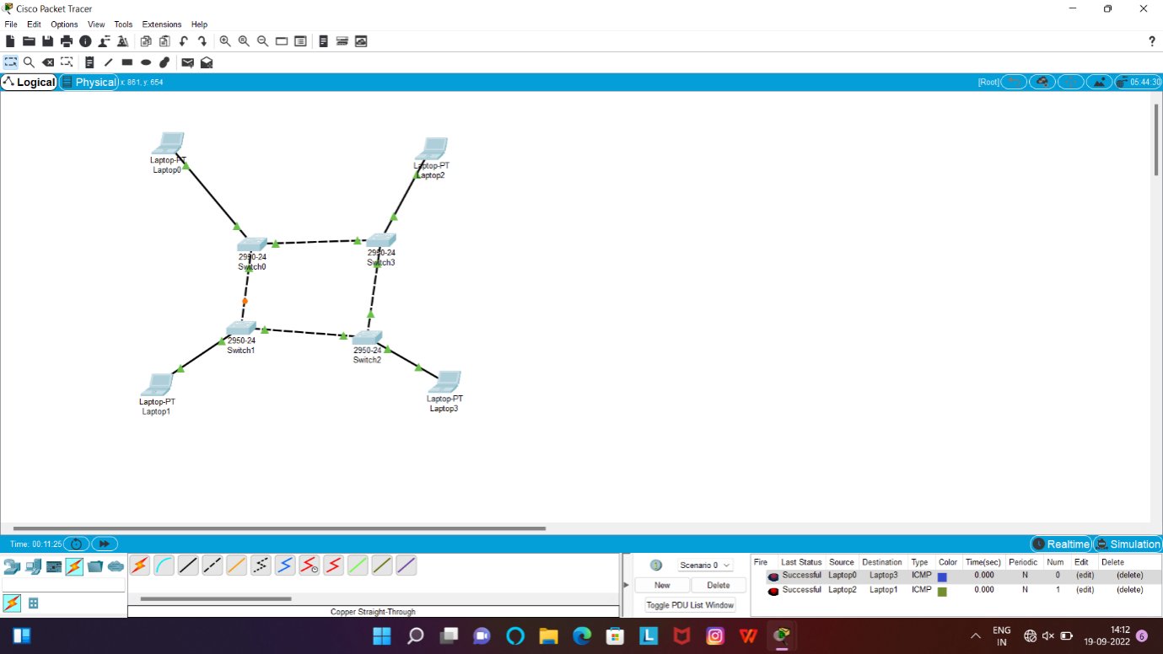

**STAR:**

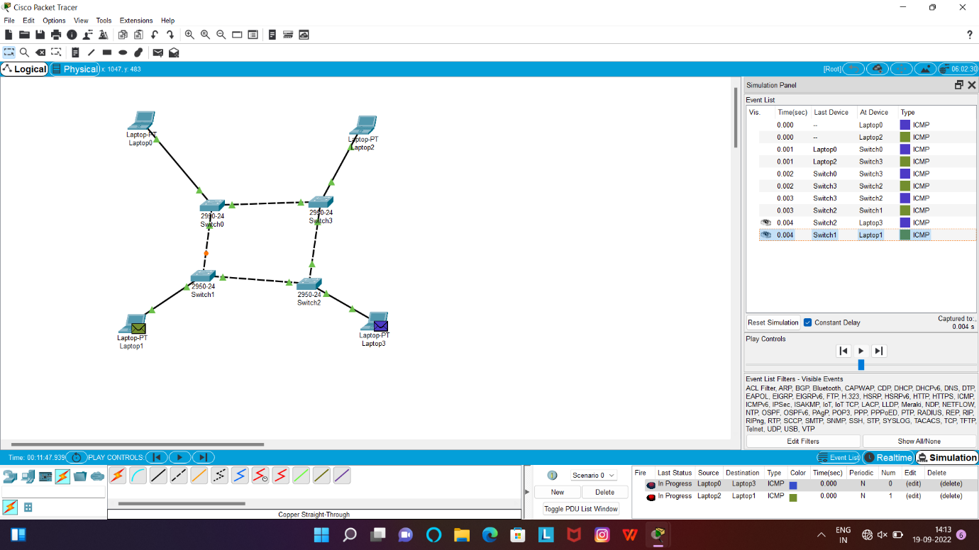

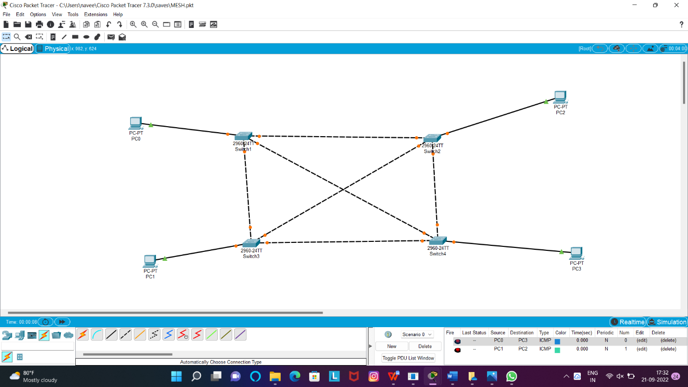

3.Configuration of Topologies using Packet Tracer (Bus, Ring, Hybrid)

BUS

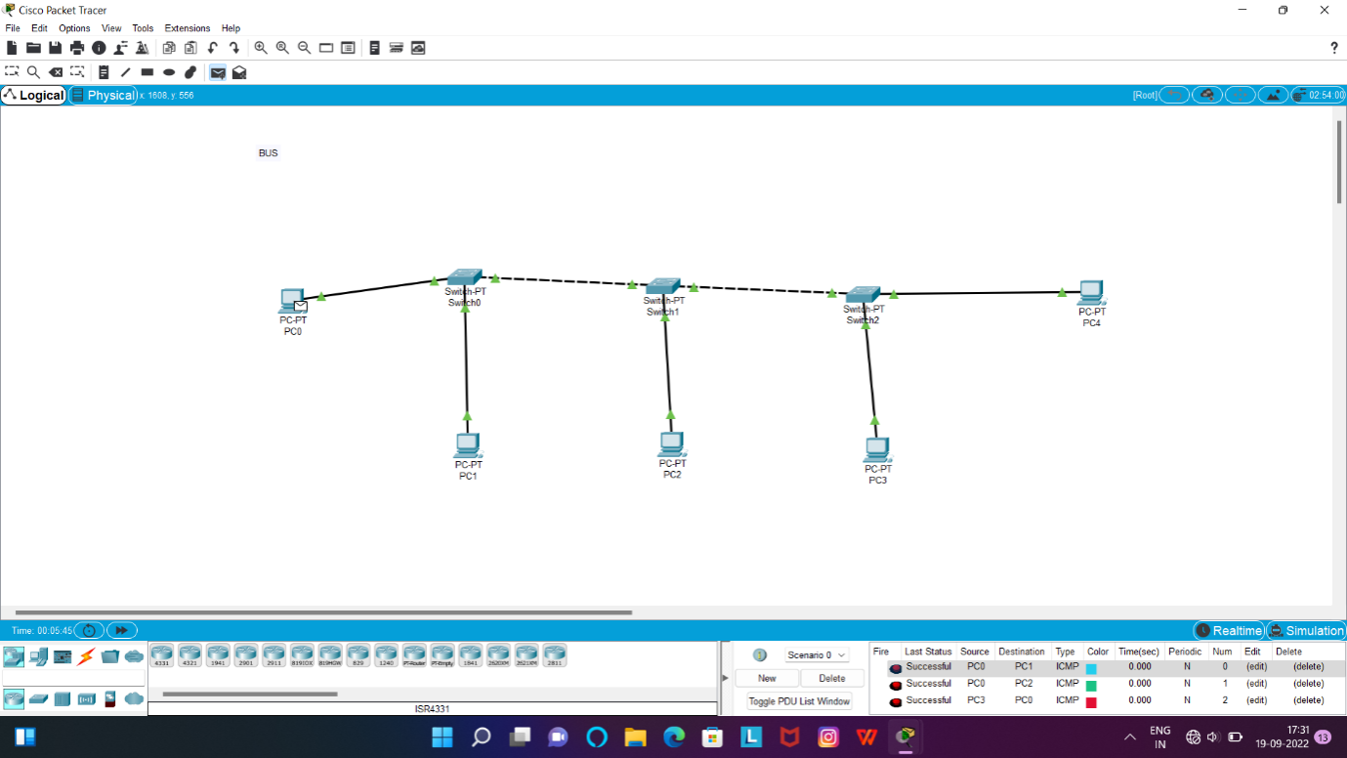

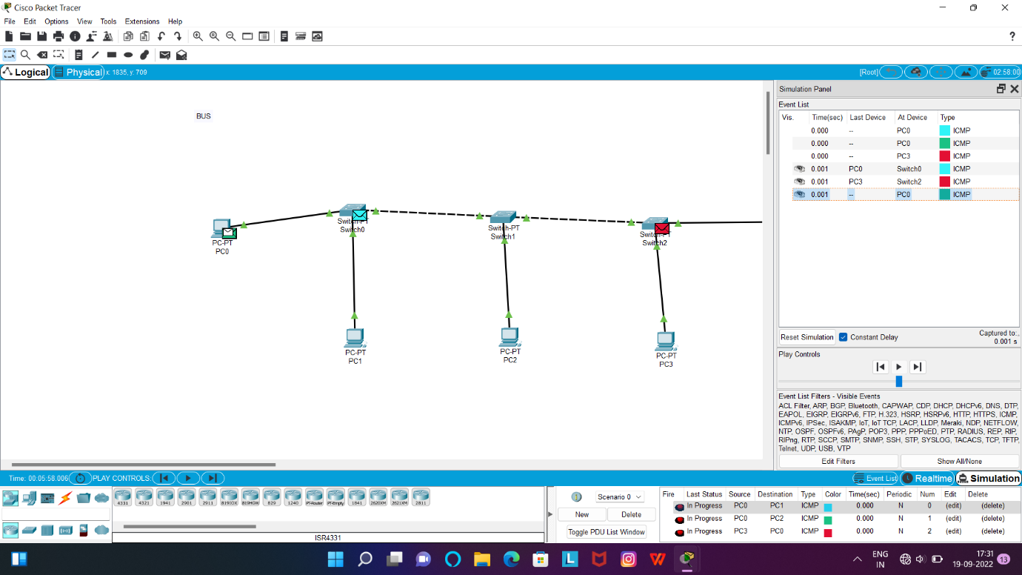

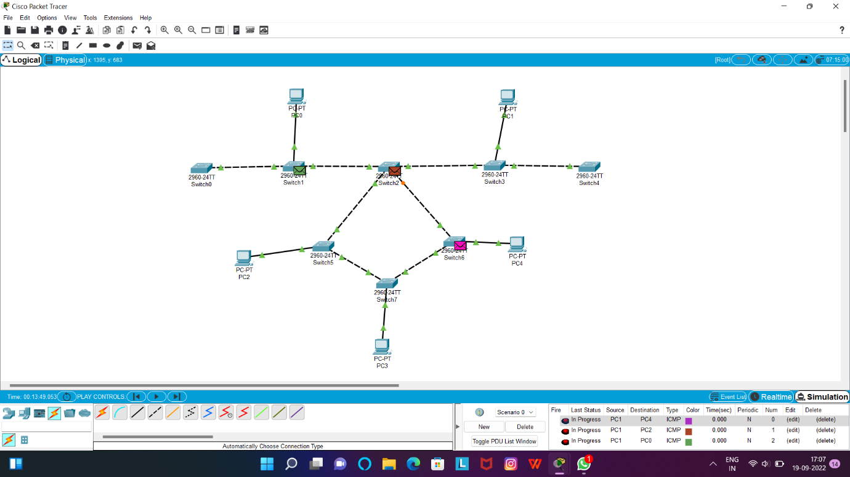

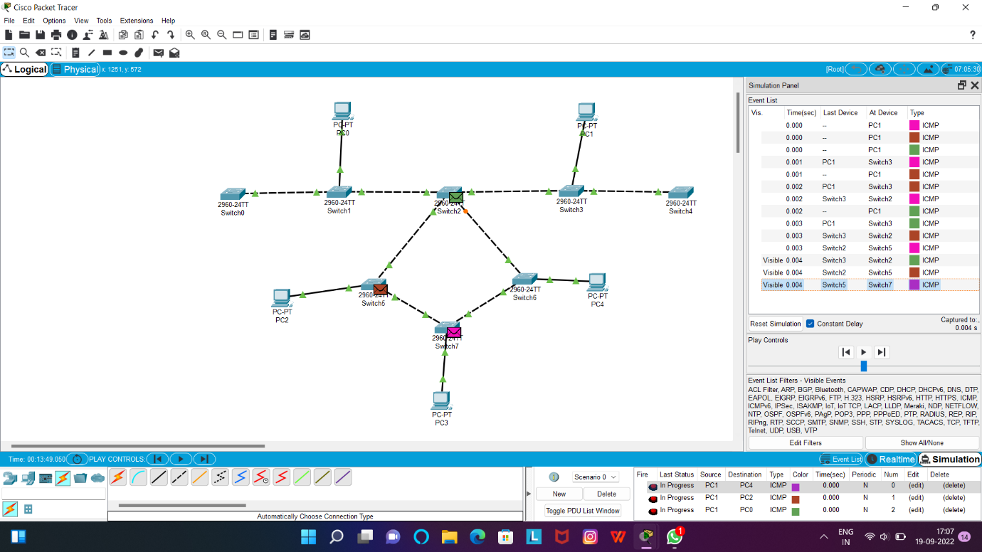

**RING**

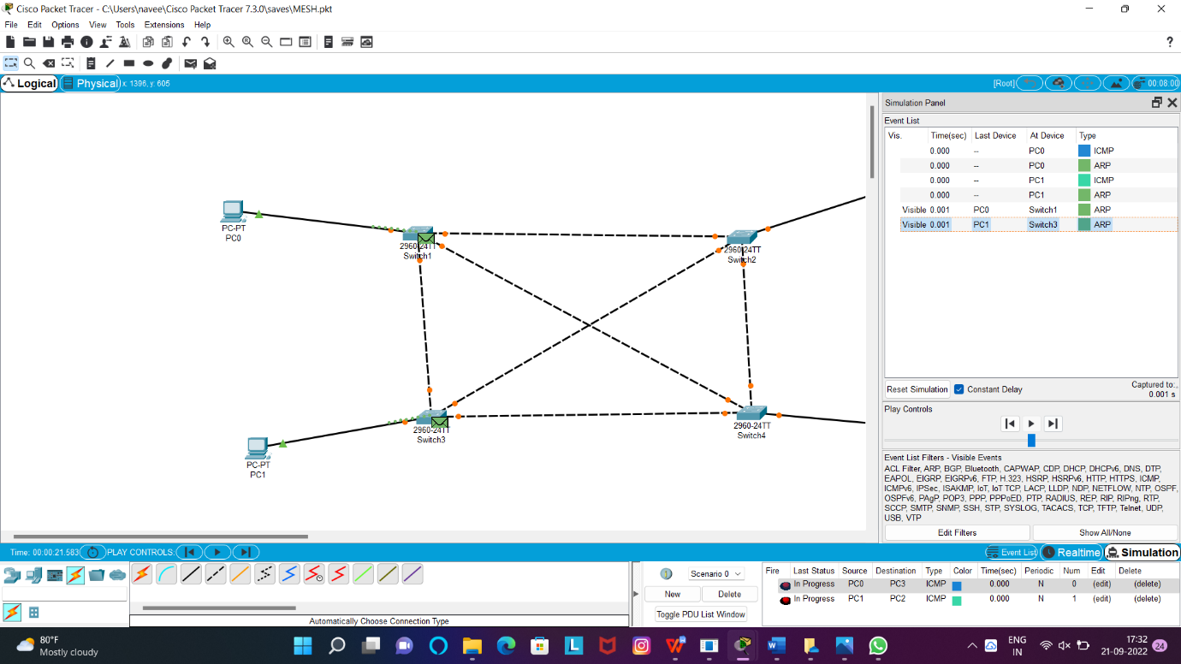

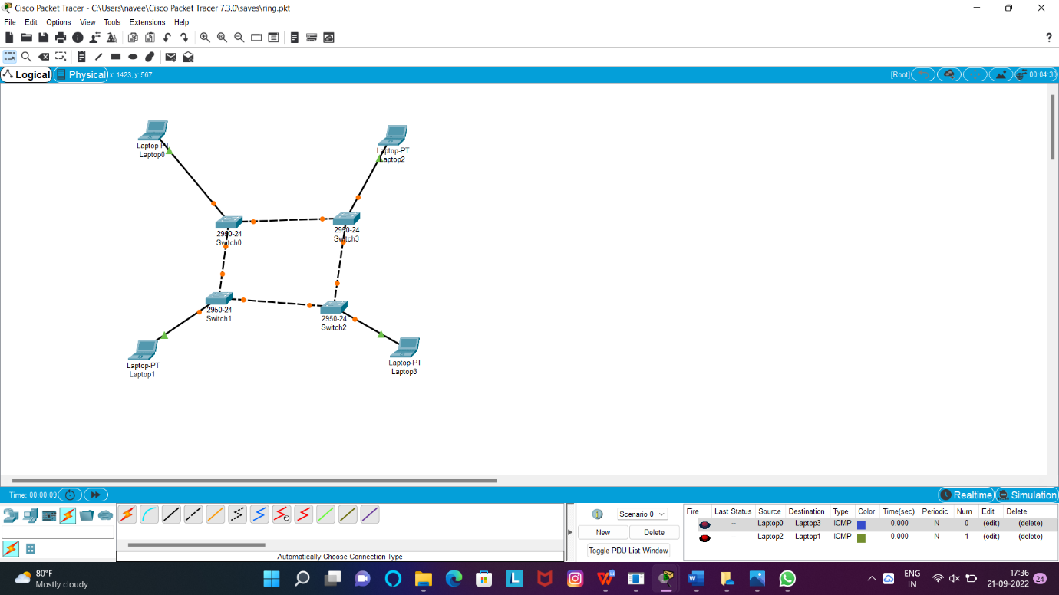

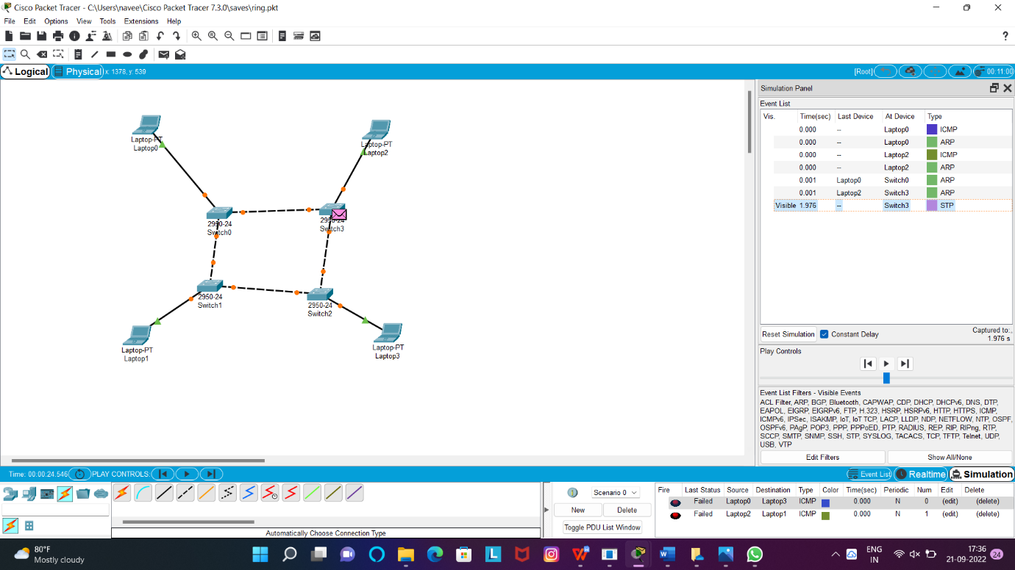

4.Data Link Layer Traffic Simulation using Packet Tracer Analysis of CSMA/CD& CSMA/CA

**CSMA/CD/CA:**

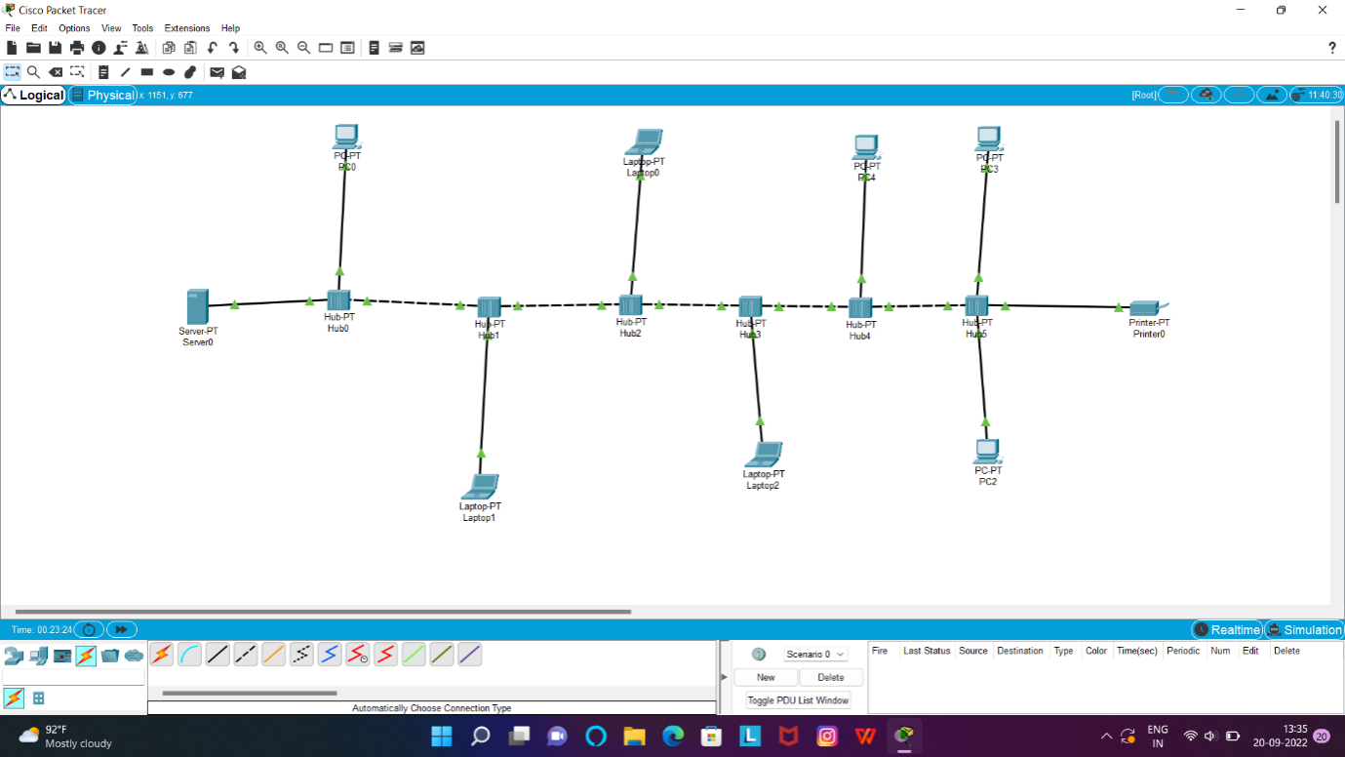

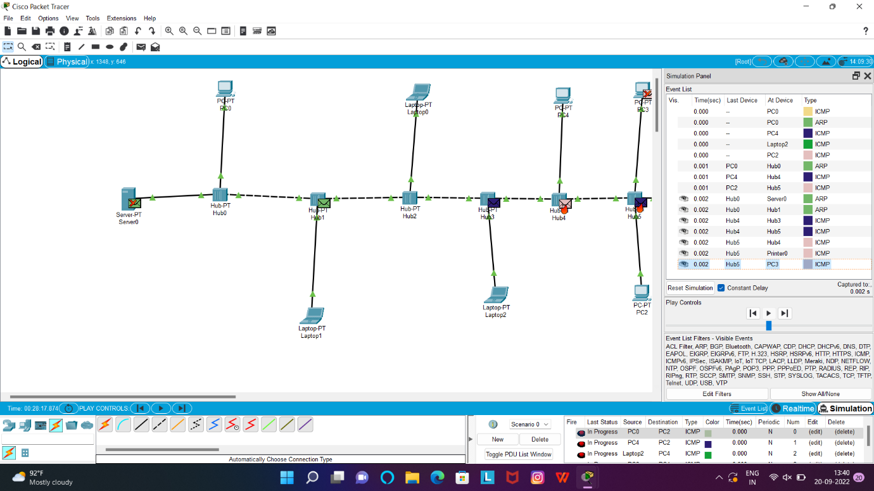

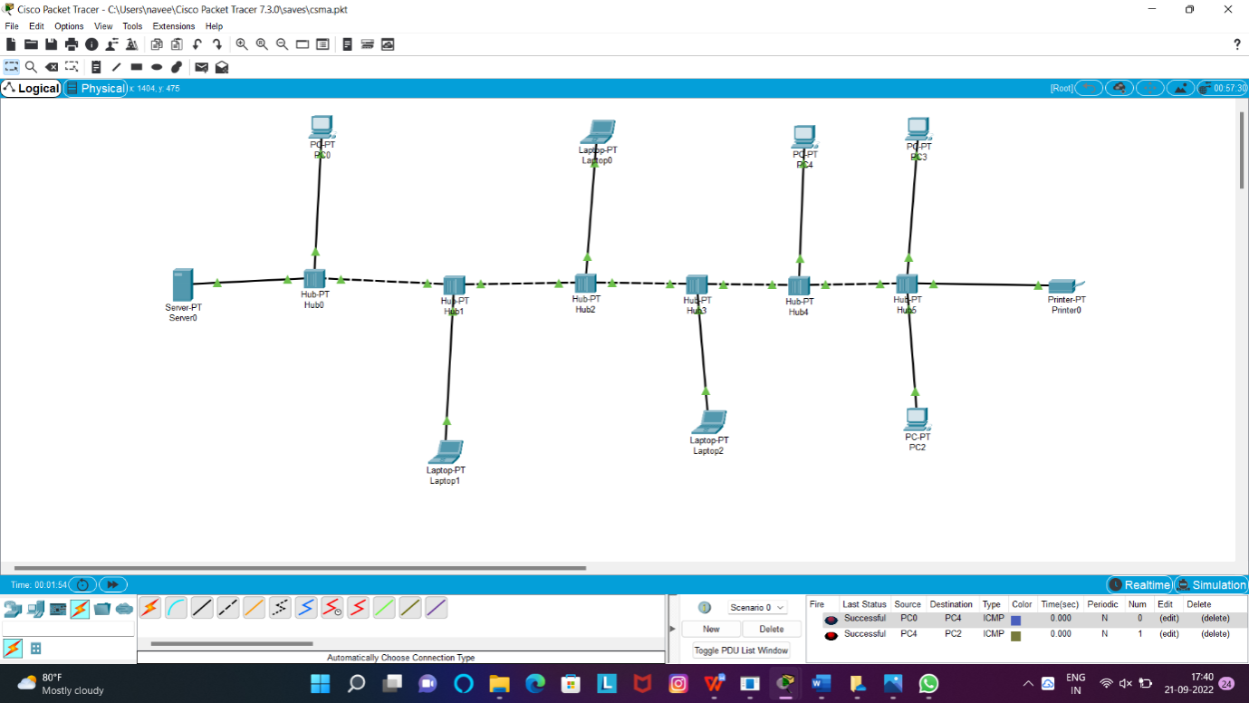

5.Data Link Layer Traffic Simulation using Packet Tracer Analysis of ARP

**ARP:**

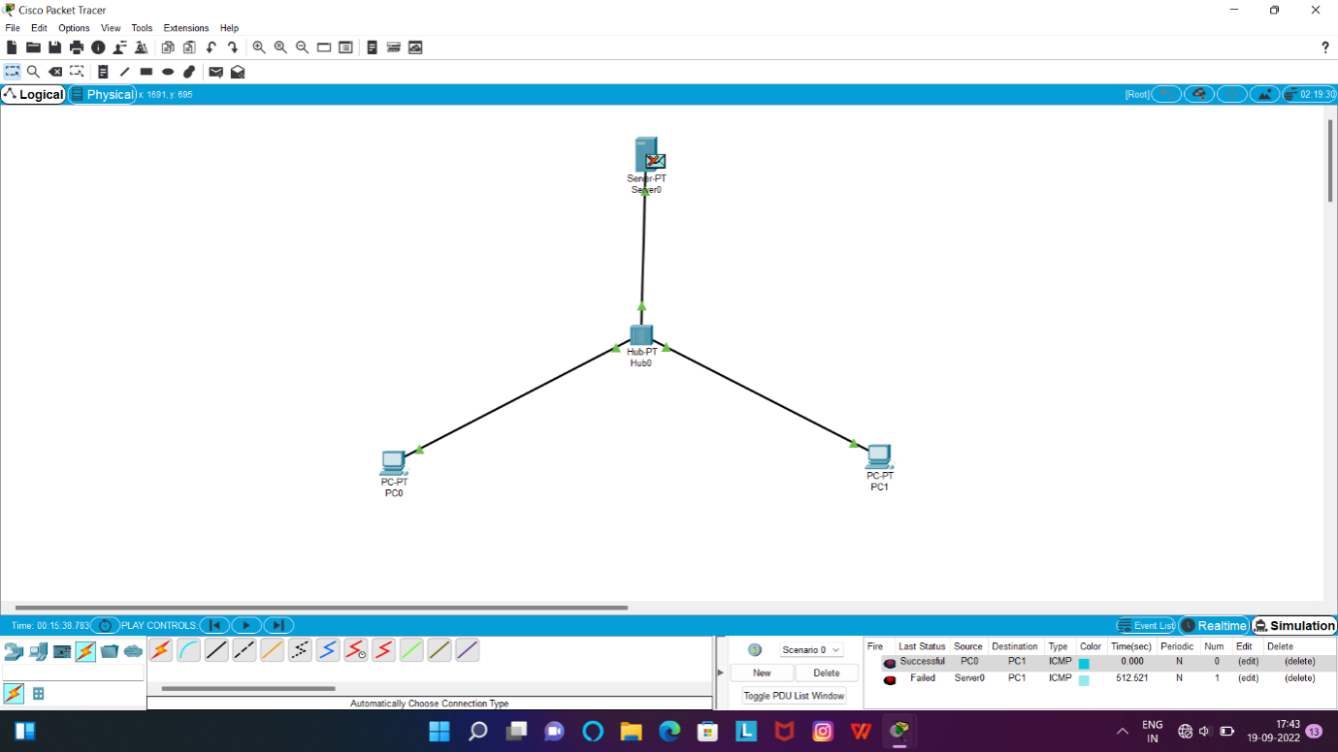

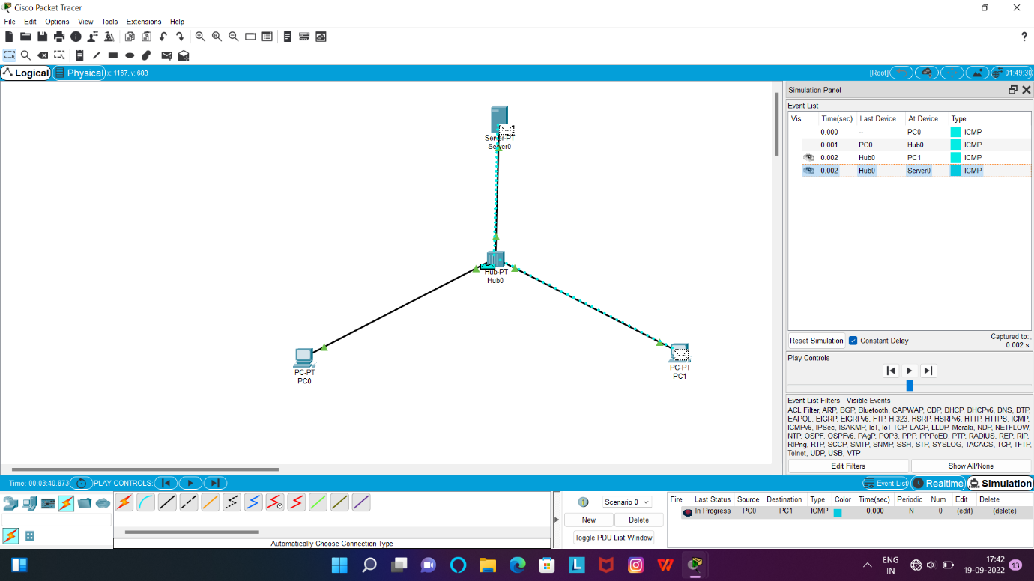

**LLDP:**

